Pennsylvania Sporting Clays Association
State Shoot Criteria, Guidelines & Application
ADOPTED 02/09/2023

Preamble – These guidelines will help shape the future State Shoot along with providing possibilities for greater clubs to apply and host the “State Championship” .

Divisions – Clubs will be placed in four(4) divisions, and shoots will be awarded geographically based on the divisions. While these divisions may change slightly base on new member clubs or some clubs discontinuing membership. If a club changes divisions based on PSCA Board voting, the club cannot hold a shoot for one(1) year.

Divisions (As of 02/10/2023)

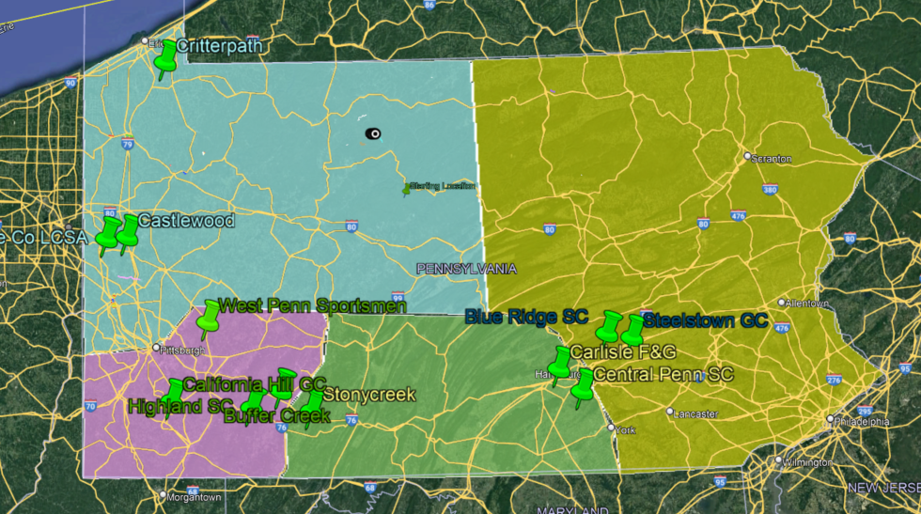

NW Division - Castlewood, Critterpath, Lawrence County
SW Division - Buffer Creek, California Hill, Highlands, West Penn
South Division - Carlisle, Central Penn, Stoneycreek
East Division - Blue Ridge, Steelstown

Qualifying for State Shoot

The club must be an NSCA and PSCA member in good standing.
2. Club Management must have held a previous significant registered shoot, a previous state shoot, or other shoot to bid at the discretion of the PSCA Board.
3. All clubs wishing to host a State Shoot must have held NSCA registered shoot(s)
during each of the following years:
i. The year prior to submitting their application.
ii. The year in which they submit their application.

Awarding of Shoots – The 2023 & 2024 State shoots have previously been awarded to Stoneycreek. Stoneycreek will maintain these two State shoots prior to these new procedures being implemented for the State Championship.

State Shoot YEAR | Geographic Division | Applications Due
2023 | South-Stonycreek | N/A
2024 | South-Stonycreek | N/A
2025 | NW | 5/1/2023
2026 | East | 5/1/2024
2027 | SW | 5/1/2025
2028 | South | 5/1/2026
2029 | NW | 5/1/2027
2030 | East | 5/1/2028
2031 | SW | 5/1/2029
2032 | South | 5/1/2030

State Shoot Award– Applications are due by 5/1 two years prior. State Shoot will be awarded, per by-laws. Any member in good standing with 300 previous year targets may vote. The vote will be online, and paper ballots provided to those not online at the State shoot. This vote will be held between 6/15 and the current state shoot, with results be announced during the State Shoot PSCA Meeting. If no club puts in for State Shoot in their geographic division for the year, applications will be accepted by any club in the state for that year. No club may hold a State shoot more than once every 3 years, unless otherwise approved by the Board.

State Shoot INFO
1. Rules – All current rules and regulations of the NSCA will be in effect.
2. The State Shoot will be at least three (3) days (Friday, Saturday, & Sunday). Additional
days may be added at the discretion of the hosting club and detailed in their shoot application.
3. Main Event: Minimum - Two (2) days - 200 Targets. (100 targets on Saturday & 100 targets on
Sunday)
4. 12 Gauge Prelim Event: At least one (1) day and 100 targets.
5. 5-Stand Event: At least two (2) days and 50 targets minimum.
6. Sub-Gauge Events (20, 28, & .410, Pump, SxS): At least two (2) days and 50 targets per event minimum.
7. The following events are optional, but strongly recommended, with at least 50 targets per
event:
i. FITASC
ii. Sub-Gauge FITASC
iii. Super Sporting
vi. Reports / Trues
vii. AFS
8. Price – All NSCA & PSCA fees MUST be included in the event costs.
9. Price – Due to extenuating circumstances (target prices, fuel costs, etc.), a host club may
increase their originally proposed event costs. Any projected increase in event costs
MUST be presented to the PSCA Board with justification and is subject to approval by the PSCA Board.
10. State Shoot Flyer – A shoot flyer must be available online (i.e. hosting club’s website,
PSCA website, etc.) at least three (3) months in advance of the shoot. The club’s
physical address, as well as the GPS coordinates if possible, and phone number must be
on the flyer.
11. Event Registration – Must be available online via an NSCA approved provider at least
four (4) months prior to the State Shoot. Registrations 45 days prior to the State Shoot
may be subject to a late fee at the discretion of the hosting club. All NSCA & PSCA fees
MUST be included in the event costs.
12. The PSCA may pay for a ½ page ad in one (1) issue of the NSCA magazine in advance of
the State Shoot. The hosting club will be responsible for the design of the advertisement
and may at their expense increase the size of the ad and/or duration in the NSCA
magazine.
13. Shooter Requirements – All PA residents who are members in good standing with the
NSCA are members of the PSCA. Any shooter, who desires to shoot the State Shoot and
is not a member of NSCA, may join on the day of the event. Hunter or Open Class may
be offered, but will be charged the same fees as those paid by NSCA members including
target fees (NSCA rule).
14. Target Requirements – Registered target requirements and associated penalties as
described in the current NSCA rule book.
15. Event Squadding – The Main, 5-Stand, and FITASC events MUST be squadded and
scheduled.
16. Scoring Software - Only NSCA approved scoring software may be utilized at the State
Shoot. Any other option must be included in the club's proposal and approved by the
PSCA Board prior to the event.
17. Leader Board – A leader board will be placed and maintained in a central location or have a Computer Monitor Scrolling.
- List all shooters
- Classes
- Concurrents
- Option results
- Show scores for all events and games
- Computer printouts or hand written will be accepted
- Tie-Breaker stations
- Protest committee
- Shooter Notifications
- Shoot-off format, schedule and location
19. All events must have trappers, even side events at the state shoot.
20. Shoot-Offs – The following must be addressed for Shoot-Offs:

Preliminary Events (Subgauge & Prelim & 5 Stand): HOA and 1st in Class will be shot-off. All other ties will
be broken by either predetermined POSTED tie-breaker stations or long run.
Main Event: HOA, Runner-Up, 1st, 2nd, and 3rd in Class, as well as 1st in all
Concurrents, will be shot off. All other ties will be broken by either
predetermined POSTED tie-breaker stations or long run.
FITASC: HOA and 1st in Class will be shot off by the rules governing FITASC.
All other ties will be broken by either predetermined POSTED tie-breaker
Parcour pegs or long run.
- Shoot-off format, schedule and locations must be approved by the PSCA Board prior to the start of the event.
- Prominent shoot-off board stating who, when and where.
- Use a pre-determined course of fire.
- Use an area not involved in the next day’s shooting.
- Three (3) pair would be recommended.
- Try to deal with the Shoot-offs as early as possible (If Sub Event ends on Friday, shoot-offs Friday for Subs)
21. GAMES – All games such as Long-Bird, Make-A-Break, Flush, etc. will be up to the
hosting club. Club rules will be in effect. However, all game rules, including payout
structure, shoot-off structure and the final winning of the event must be clearly written
down and POSTED at the Leader Board and the place where the shooting is to be done.

State Shoot Trophy & Awards

REFER TO STATE SHOOT AWARD PROCEDURES ADOPTED BY BOARD AT TIME OF STATE SHOOT

Shooting Ground Requirements
1. Insurance – The shooting ground owner or promoter shall be required to furnish
insurance for the EVENT and a certificate of insurance will be on hand at the time of the
shoot. The policy must list the PSCA as well as the Shooting Ground, and Shoot
promoter. This insurance will be the responsibility of the owner/promoter and not the
PSCA.
2. Referees – Referees must be Certified NSCA Referees or must be trained by an NSCA
Certified Referee prior to the shoot. The score keepers will be responsible for keeping a
master sheet on the course. Each shooters score will be recorded twice, once on the
individual score sheet and once on the master sheet. Two (2) Certified NSCA Referees
must be available for the shoot.
3. Drinking Water – There MUST be water at LEAST every third station regardless of
distance between stations.
4. Rest Rooms – There must be rest rooms (portable facilities) set up at no less than three
locations on the course. This is not to preclude the placing of facilities at the 5-Stand
location or the FITASC Parcours. These facilities must be maintained during the weekend.
5. Gun Racks – There must be a gun rack at each shooting station.
6. Shooting Cages – Shooting boxes are to be constructed to prevent a chance injury (i.e.
boxes that can tip over, have bad flooring, and that are poorly constructed, should not be
used).
7. Traps – Strongly recommended that courses use all automatic traps. In the event that
manual traps are utilized, it is recommended that they be kept to a minimum (i.e. no more
than two (2) on an entire course.)
8. Annual Meeting – Facilities for the Annual Meeting must be provided (seating, public
address, and lighting)

Disclaimer

- The PSCA Board may amend these regulations at any time with a Board vote.
- The PSCA Board may amend Payout and awards based on Budget with a Board vote.
- The PSCA Board wished to have the clubs propose “Their” state shoots. We will not dictate all aspects of the State shoot. Propose your State and it will be voted on.

Guidelines – Adopted 02/09/2023 _______________________________________

